1. 1. Write a program to calculate the value of ex [Hint : ex =1+x+x2/2!+x3/3!+…..]
   2. Draw a graph of y= ex
   3. A professor wants to know if her introductory statistics class has a good grasp of basic math. Six students are chosen at random from the class and given a math proficiency test. The professor wants the class to be able to be to score above 70 on the test. The six students get score of 62,92,75,68,83 and 95. Can the professor have 90 percent confidence that the mean score for the class on the test would be above 70?
2. 1. Python Program to remove a specific digit from every element of the list [HINT: Input : test_list = [333, 893, 1948, 34, 2346], K = 3]
   2. Draw the dashed line graph y=5 in red color. Show the legend in upper left corner.
   3. When an unbiased coin is tossed eight times what is the probability of obtaining: (a) less than 4 heads (b) more than five heads?
3. 1. Write a program that inputs a text file. The program should print all of the unique words in the file in alphabetical order.
   2. Draw a bar chart showing Types of determiners v/s count
   3. A public opinion poll surveyed a simple random sample of 1000 voters. Respondents were classified by voting preferences to parties A, B and C and by gender (male or female). Results are shown in the contingency table below. Is there any gender gap? Do the men’s voting preference differ significantly from the women’s preferences? Use 005 level of significance

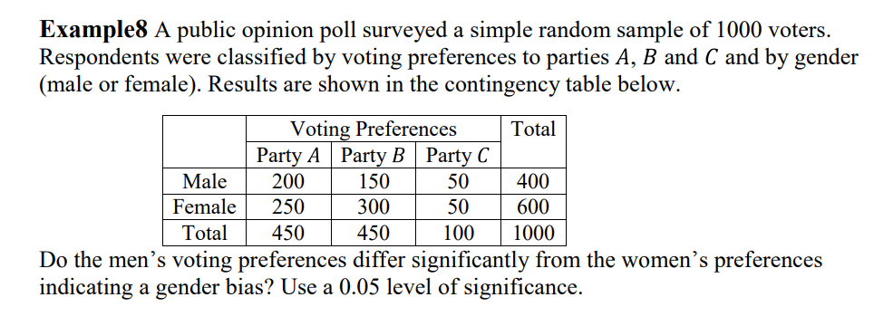

1. 1. Write a program to print the trace of a matrix
   2. Write a Python programming to display a bar chart of the popularity of programming Languages. Use different colour for each bar.

Sample data:

Programming languages: Java, Python, PHP, JavaScript, C#, C++

Popularity: 22.2, 17.6, 8.8, 8, 7.7, 6.7

* 1. A drug is found to be 90% effective in curing a certain disease.
     1. If 500 people are treated with the drug, what is the expected number of patients who will be cured?
     2. What is the standard deviation of the number of patients cured in a sample of size 100?
     3. If 100 people are given the drug, what is the probability that exactly 99 will be cured?
     4. If 500 are treated, find the probability that more than 400 will be cured. (Use a normal approximation.)

